WINCHESTER & DISTRICT SCOPE
supporting people with cerebral palsy
FULLY REGISTERED AS A CHARITY (No. 224714)
Tel: 01962 880734 email: secretary@winchesterscope.org

Saturday 10 September 2016
St.BARNABAS CHURCH, FROMOND RD. WINCHESTER
Join us at 2pm for tea and cakes
2.15pm Clair Padgham to talk about plans for
RACERUNNERS
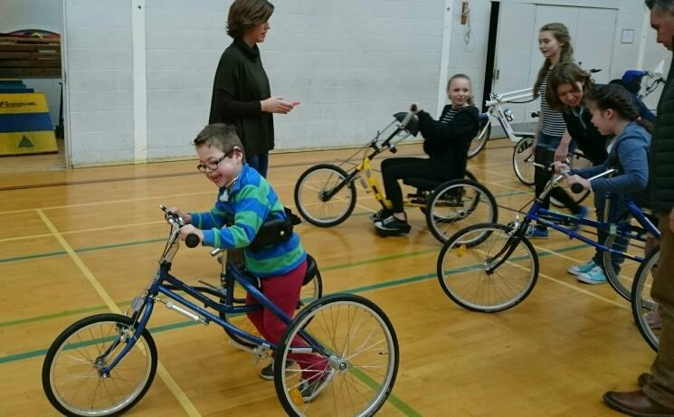

2.45pm BREAK FOR MORE TEA AND CAKES
Chance to chat, socialise and allow children
free to play.

3.15pm AGM Business
Minutes for last year - Annual Report & Accounts,
- Questions and comments welcome
Voting in Executive Committee Members
- New Treasurer to be welcomed
- Return of old Executives
- Invitation to anyone wishing to join our
Executive Committee

4.00pm CLOSURE

- New Executives welcome

