PUBLICITY
We know we must publicise the service we offer as best we can. In the past it was leaflets, posters and our Annual Report. We developed our website to improve our publicity but it fell between two stalls recently and so we have been working hard to make it fresher and up to date. Go now to http://www.winchesterscope.org.
WEBSITE: We must thank James Rose for his years as our webmaster. He began working on our new look website in a format that we will be able to keep updated ourselves.
James has moved on now and lives in London (we hope he has made a good recovery after a recent op).
We must also thank Peter Dudley for picking up on our website and helping us to master the art of editing. We plan to present it at our AGM and ask for ideas & opinions on how it looks and possible improvements.

ANNUAL REPORT: This year we agreed to reduce the size of our Annual Report to save costs and enable us to email it with invitations to our Cream Tea & AGM. Some will need to be posted...
LEAFLETS: We are updating it and will produce a few but again, we hope our website will do the job better
DIRECTORIES : We regularly update our information in on= line directories such as Evolve, NHS Directory, HCC Adult Services and Hampshire Neurological Alliance .Directories.

EXECUTIVE MEETINGS WERE HELD

10th April & 6th June 2014
AGM
20th September 2014

10th November 2014 & 23rd February 2015

Winchester & District Scope
Registered Charity 224714
ANNUAL REPORT
2014 to 2015
Chair and Secretary’s Report – Past Year’s Activities
The year began with a surprise from national Scope. Affiliated to them since 1963/4 , they were no longer willing to link with groups like ours on their website though wanted to keep our information on record to signpost enquiries to us. We sent our details and expressed some disappointment. Now rebranded, Scope no longer specifically relates to cerebral palsy but is a pan disability organisation enabling them to lobby on wider issues.

So we were pleased to hear from an old friend, Nigel Marsh, Senior Regional Response Officer for Scope Response: he remains involved with individuals and families, focussing on cerebral palsy (cp). We will continue to keep in touch with him.

Also, as a result of our changed relationship with Scope, we had to amend our constitution which gained approval at the AGM and from a sufficient percentage of General Members to be accepted by the Charity Commission.

At last year’s AGM
Marie Boxall talked about the excellent work of Face2Face. a befriending service for families of disabled children. The Befrienders are themselves people who have disabled children and can offer support and advice based on their own experiences. They aim to attract more Befrienders to widen the spread of the service to cover our area.

Liz Dudley agreed to stand as Chairman for one year, Nicki Wade Vice Chair and we were very glad to welcome 3 new Members to our Executive Committee – Gill Young, retired Osborne School Teacher, Trudie Christmas Paediatric OT Assistant and Jo Syvret mother of a little girl with cp. We’ve had a good strong Executive Committee this year.
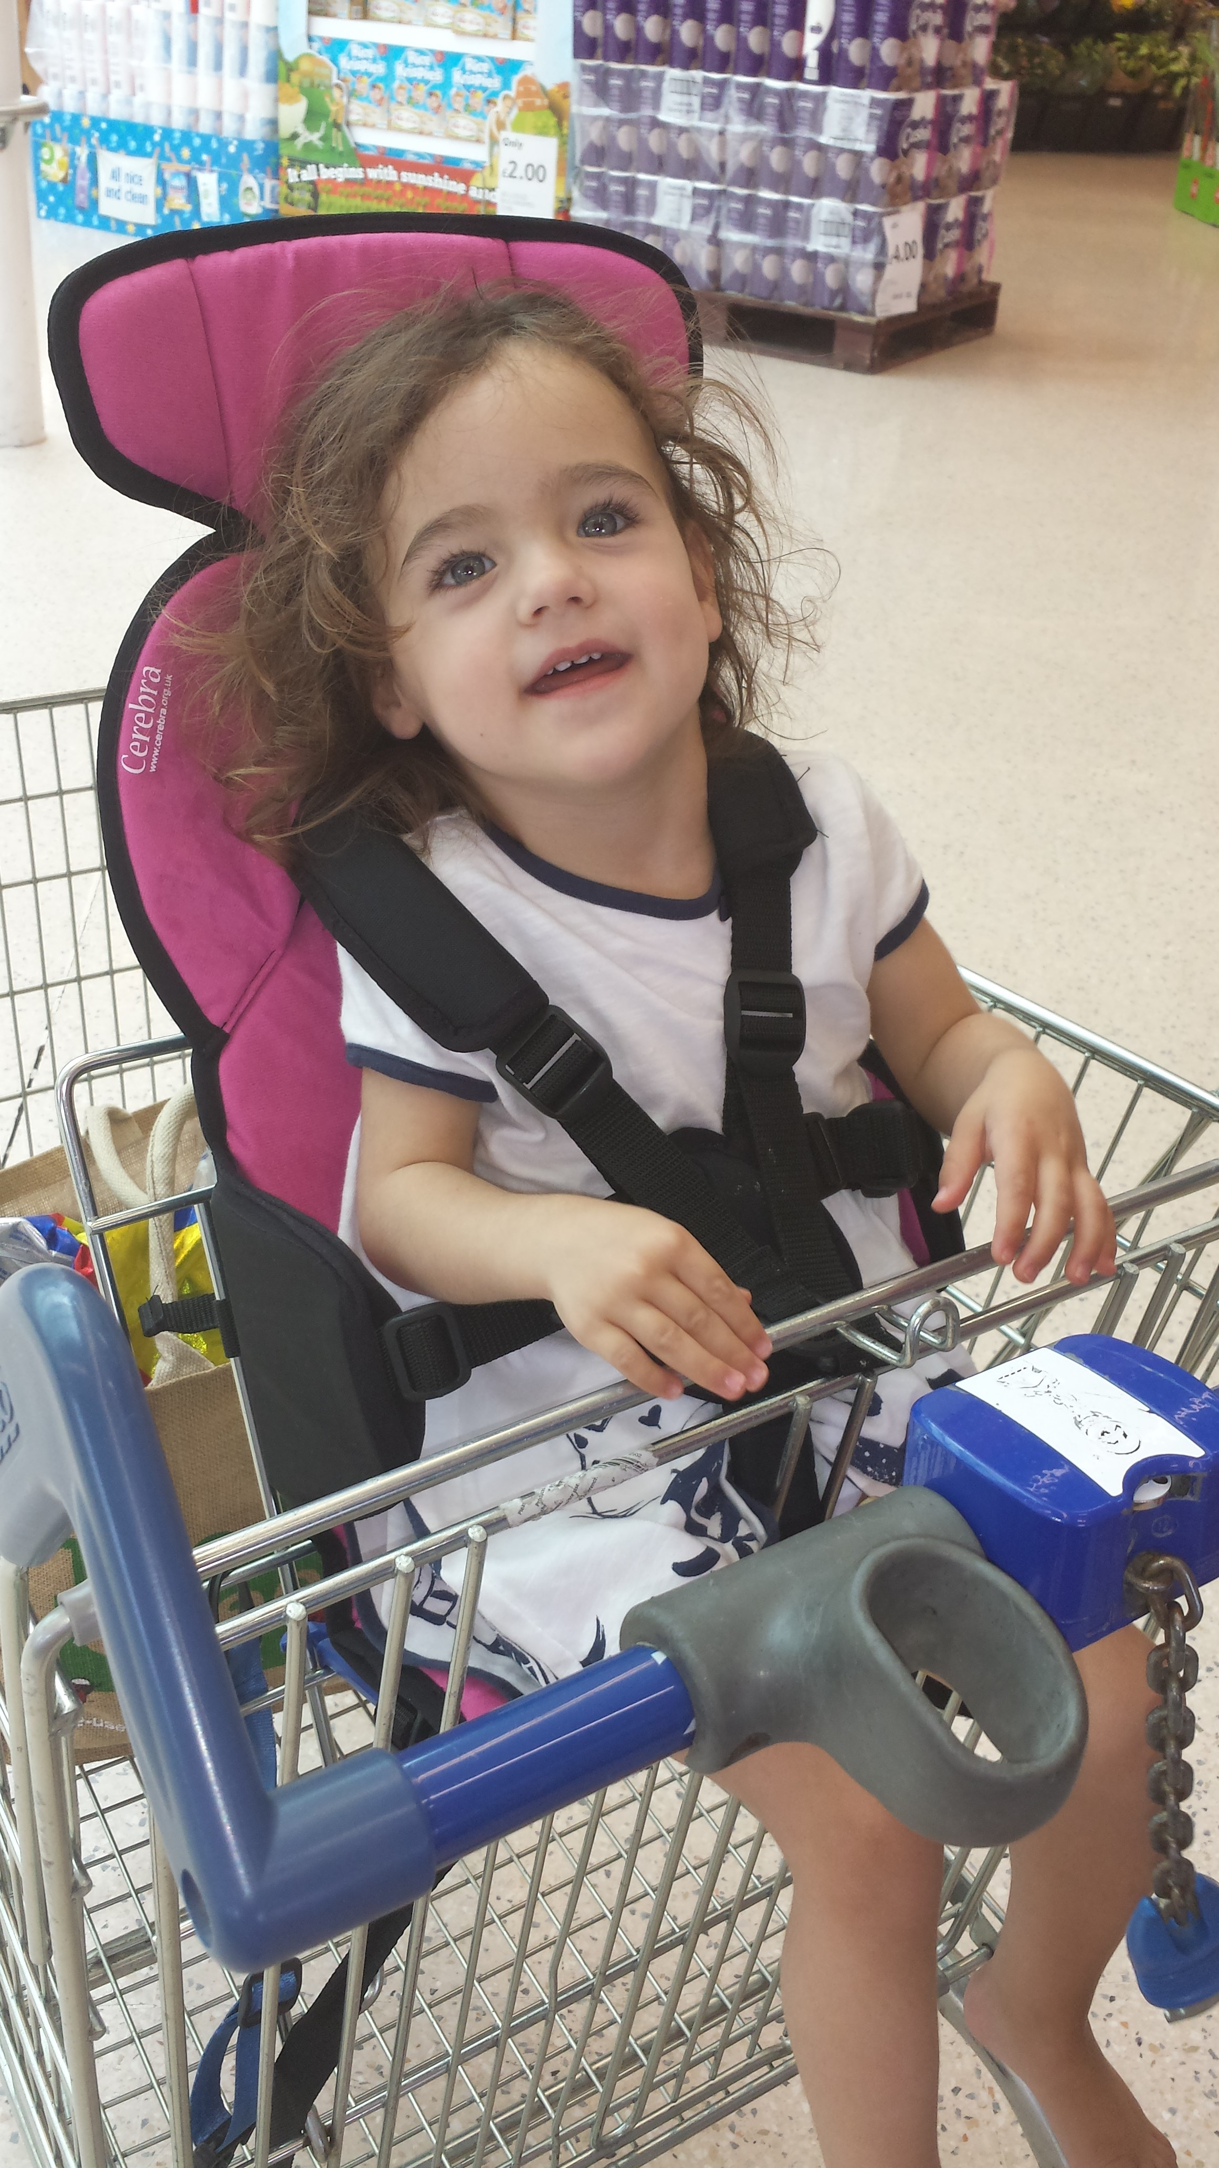

Connie comfy out shopping

Co nnie comfy out shopping
The cream tea again proved very popular.
DONATIONS MADE BETWEEN
6th April 2014 & 5th April 2015 £
Post-Op Physiotherapy 525.00
Holiday 750.00
Rainbow Centre Fees 621.00
Wheelchair repair 220.00
Car Seat 135.00
Transport Costs_ __750.00 TOTAL £ 3,001.00

Connie comfy shopping
Our Main Role - Requests for grants
We have been able to respond quickly to all
requests – sometimes in full and for others we
have contributed towards the cost of more expen-
sive items, at times working with other sources of
financial help. Although most of our requests
come via the Occupational Therapists, some
have come direct to us and we always keep
our eyes open for newspaper appeals for fund-
ing for children with cp in our patch.

EXECUTIVE COMMITTEE 2014/15
Chairman Liz Dudley
Vice-Chair Nicki Wade
Hon.Treasurer Karen Millachip (resigned July 2015)
Charlotte Smallman (from July 2015)
Hon.Secretary Shirley Kenneally
Trudie Christmas, Sarah Dearing, Jez Holder, Cheryl Honeycombe, Helen Rich, Jo Syvret & Gill Young. Financial Examiner Adrian Reeves

Our General Members are kept in touch with important issues coming
from HCC such as the ”Consultation on changes to Short Breaks” and we keep up with wider voluntary sector activities. We were impressed by what we saw at the Rainbow Centre on it’s Open Day and were glad to hear that they had tackled their financial difficulties and are now on a more viable footing . They aim to expand to deal with adults and youngsters in their transitional stage.

MANY THANKS FOR DONATIONS RECEIVED
From the bequeathed share of a stamp collection, to a supporter’s donation and well wishers who asked friends and family to donate to us in lieu of their wedding
presents having seen how we had helped a little girl known to them.
INCOME & EXPENDITURE ACCOUNT FOR YEAR ENDING 05.04.2015
Income Expenditure
2013/14 2014/15 2013/14 2014/15
44 Donations 1,672 943 Administration 1.014
Fundraising - 5,194 Gifts 2,476 4,911 COIF Fund Interest 4,781 575 Grants 525 - HMRC Gift Aid - - - Fund Raising -- - Repayments 21 Unpresented
cheques 05/04 -
4,955 Total Income 6,474 6,712 Total
Expenditure 4,015
1,757 Excess Exp/Inc - Excess Inc/exp 2,459
_____ ____ _____ _____
6,712 Total 6,474 6,712 Total 6,474

